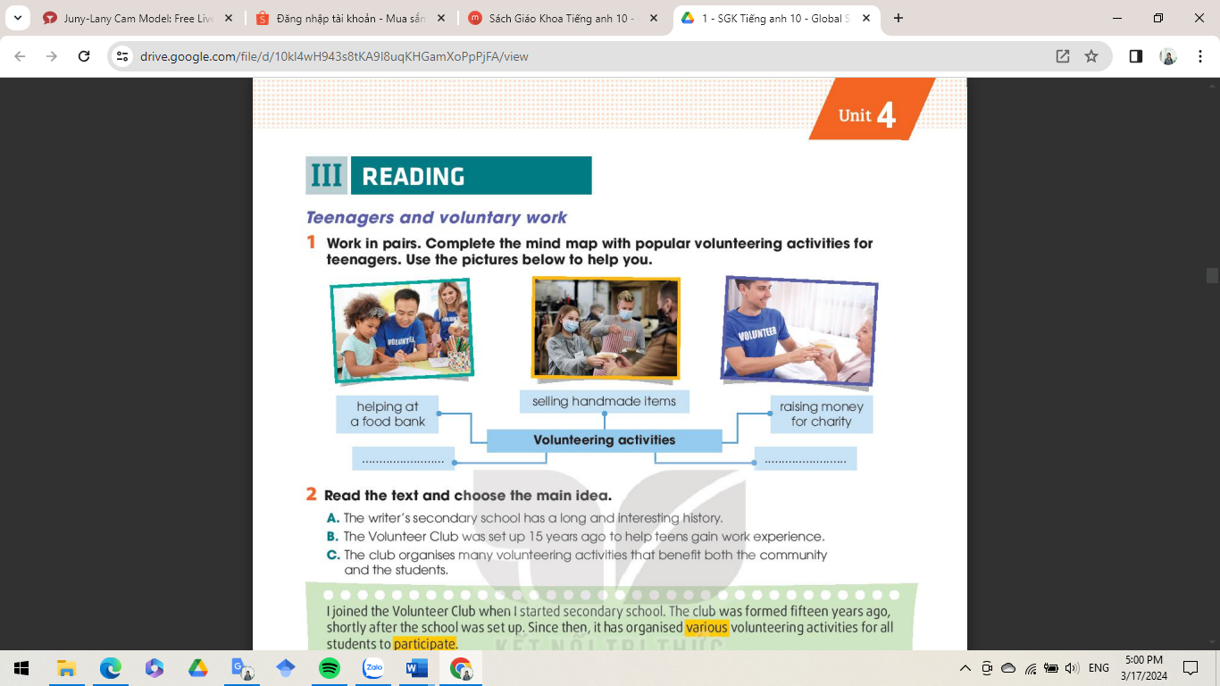

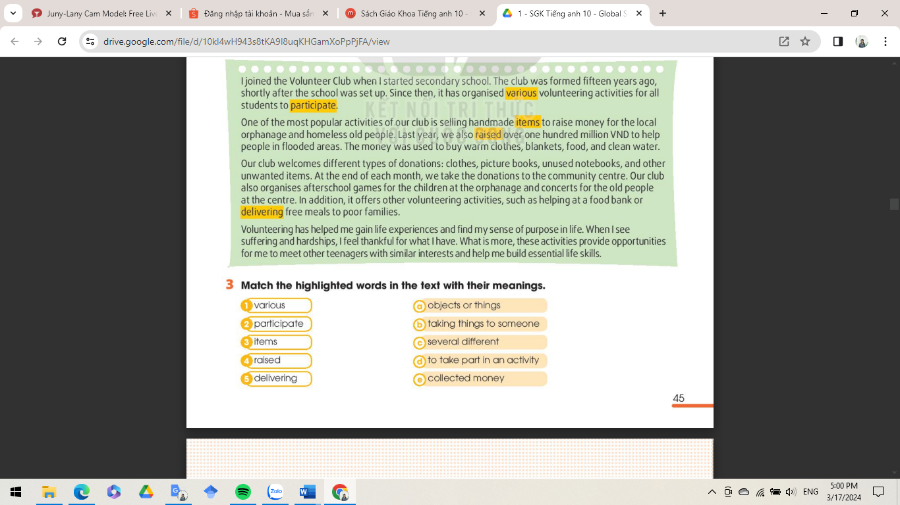

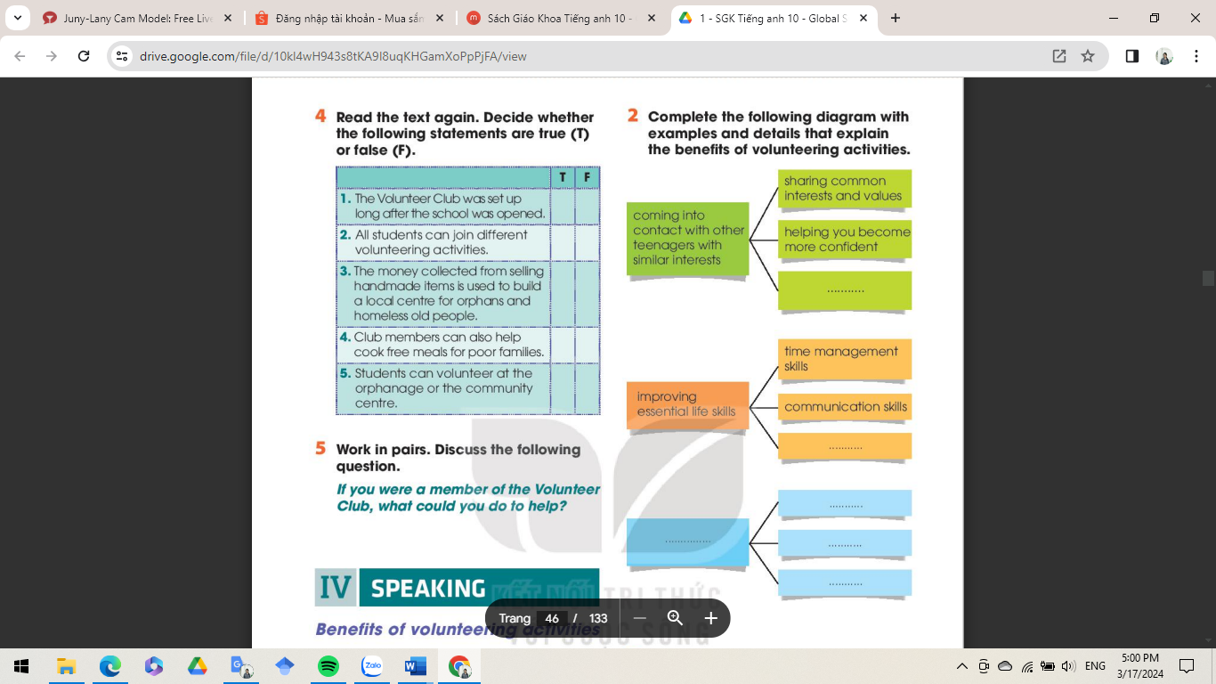

**LESSON PLAN**

**Unit 4: FOR A BETTER COMMUNITY**

**Lesson 3: Reading**

**Time : 45 minutes**

**Grade: 10**

**I. OBJECTIVES**

By the end of the lesson, students will be able to:

1. **Knowledge**

- identify the benefits of volunteering activities.

- use new words about the topic of voluntary work.

1. **Skills**

- predict the meaning of new words from the context.

- identify the main ideas in the passage.

- pick out details of the reading text

1. **Attitudes**

- operate and support in pair work and teamwork.

- support doing voluntary work to help the social community.

**II. TEACHING AIDS AND MATERIALS**

- Teacher: textbook Global Success 10, lesson plan, powerpoint, gift,...

- Student: textbook Global Success 10, notebook,...

**III. ANTICIPATED PROBLEMS**

- Problem: Ss may not sufficient vocabulary to speak

- Solution: Teacher should provide them with knowledge about volunteer works

**IV. TEACHING PROCEDURE**

|  |  |  |  |
| --- | --- | --- | --- |
| **Time** | **Stages/ Aims/ Contents** | **Teacher’s activities** | **SS’ activities** |
| 5 mins | **WARM – UP:** GAME - LUCKY NUMBER  **Aim:** recall the use of some tenses  **Choosing the number:**  *1. When do we use the past simple?*  2. *When do we use the past continuous?*  *3. List words as signals of the past simple.*  *4. Complete the sentence:*  *While I (listen) ___to music, he (knock) ___the door.* | - divides class into 2 teams  - gives and checks instructions  - lets Ss join the game  - gets the results and decides the winner | - follow T’s instructions  - join the game |
| 7 mins | **PRE-READING**  **Aims:** identify the benefits of volunteering activities  **Vocabulary:**  Set up = establish = thành lập  Hand-made (a) = làm bằng tay  Hardship (n) = sự gian khổ  Suffering (n) = sự đau khổ  **Task 1: Mindmap**  **Work in pair. Complete the mind map with popular volunteering activities for teenagers. (p45)**  ***Suggested keys:***  *- Helping the old cook meals, buy food,...*  *- Helping the old with technology (send emails, use Internet, or install apps),...* | - guides ss to read the vocabulary  - calls some ss to repeat  - asks Ss to work in pairs & draw the mind map.  - encourages Ss to use the pictures as clues.  - calls some pairs to present their answer.  - gives feedback. | - listen, repeat and take note  - do the task with their partner. |
| 25 mins | **WHILE-READING**  **Aims:**  - Identify the main ideas in the passage.  **-** guess meaning of words from the context.  - scan for specific information.  **Task 2: Read the text and choose the main idea.**  ***Answer key:* C**  *A: not mentioned in the text.*  *B: Helping teens gain work experience is not the aim of the club.*  **Task 3: Match the highlighted words in the text with their meanings.**  ***Answer keys:***  1. c 2. d 3.a 4. e 5. B  **Task 4: Decide whether the following statements are true (T) or false (F). (p46)**  ***Answer keys:***  *1. F (shortly after)*  *2. T*  *3. F (to raise money for the local orphanage and homeless old people)*  *4. T*  *5. F (deliver free meals)* | - gives and checks instructions  **-** asks Ss to read 3 options to check their understanding.  - asks Ss to read the text once and choose the main idea.  - invites some pairs to answer.  - checks answers.  **-** asks Ss to look at the text, pay attention to highlighted words, and read the text again.  - asks Ss to work individually  - calls some Ss to go to the board to write the answers.  - checks answers with class.  - asks Ss to read the questions and underline the key words.  *-* reminds Ss that the statements may include paraphrased or opposite information in the text.  - tells Ss to read the text fast and use key words they underlined to find out answers.  - calls Ss to present the result and asks them to give reasons for their answers.  - gives feedback. | - follow T’s instructions  - read the text and work in pairs  - read the text again to guess the meaning from the context, then match the correct given meaning.  - compare and discuss the answers with their partner.  - follow T’s instructions  - read the text and work in pairs |
| 8 mins | **POST- READING**  **Aims:** express ideas about doing voluntary work to help the social community.  **Task 5: Discussion**  **Work in group. Discuss the question (p.46)**  *If you were a member of the Volunteer Club, what could you do to help?* | - lets Ss work in group and discuss the question.  - calls some groups to present their answers in front of class.  - gives feedback. | - work in group  - present the answer in front of class.  - give comments for their friends and vote for the most interesting and informative presentation. |