**INPUT E6-U5-GS-p48-49**

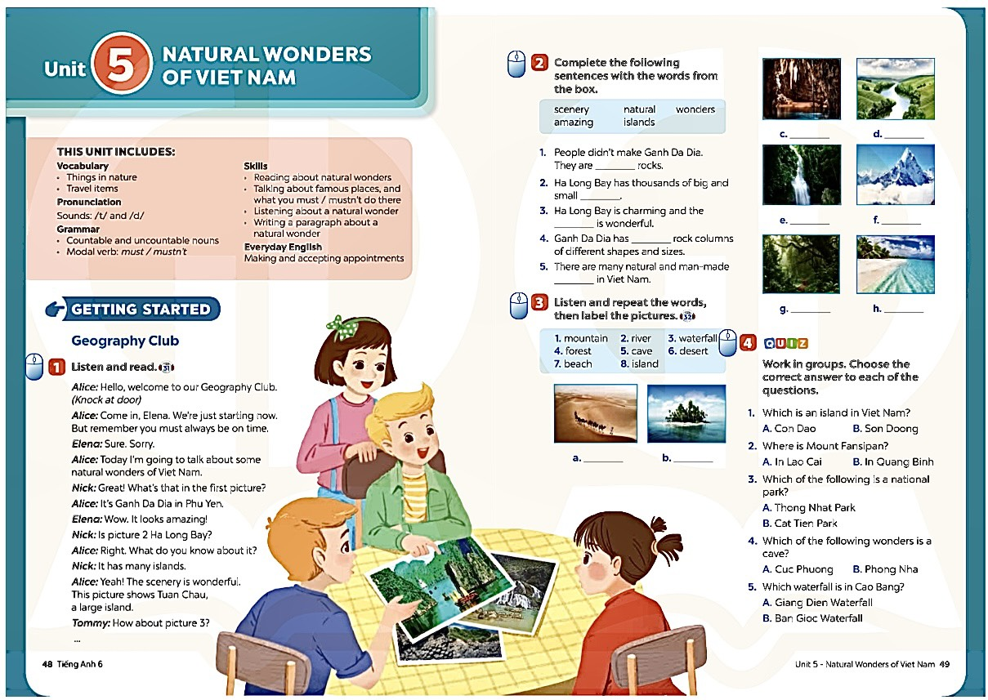

**School: Date:**

**Class: Period:**

**UNIT 1: HOBBIES**

**Lesson 1: Getting started – My favorite hobby**

**I. OBJECTIVES:**

By the end of this lesson, Ss will be able to:

**1.1. Knowledge:**

- Have an overview of the topic Hobbies.

- Gain more vocabulary to talk about hobbies.

**1.2. Core competences:**

- Improve pronunciation and intonation.  
- Comprehend the conversation related to the topic.

**1.3. Attributes:**

- Share personal hobbies.

- Manage time for hobbies.

**II. TEACHING AIDS AND MATERIALS:**

- Teacher’s aids: Grade 7 textbook, Unit 1, Getting started, computer connected to the Internet, projector / TV/ pictures and cards

- Students’ aids: student’s book, workbook, notebook.

**III. PROCEDURES:**

**Activity 1: Categorizing hobbies:**

-Have ss complete the table:

- Teacher allows students to share answers before discussing as a class.

- Write their answers on the board. Have Ss add more words to the table.

- Check ss’ answers and confirm the correct ones.

|  |  |  |
| --- | --- | --- |
| **Doing things** | **Making things** | **Collecting things** |
| *- riding a horse*  *- gardening*  *- others (doing yoga, skiing, travelling,…)* | *- painting*  *- making scrapbooks*  *- others (making pottery,…)* | *- collecting books*  *- collecting stamps.*  *-others (collecting toys, collecting coins…)* |

**Answer keys:**

**Activity 2: Pre-teaching vocabulary.**

-Have ss learn the new words:

1. building dollhouses (v): xây nhà búp bê (translation)

2. collecting coins (v): sưu tập đồng xu (explanation)

3. collecting teddy bears (v): sưu tập gấu bông (visual)

4. making models (v): làm mô hình (translation)

-Teacher introduces the vocabulary.

-Teacher checks students’ understanding with the “Rub out and remember” technique.

**Activity 3: Setting the scene:**

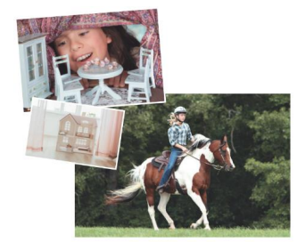- Have Ss look at the pictures in the book and answer the questions:

**Questions:**

*1. What can you see in each picture?*

*2. What may the hobby be?*

- Teacher asks Ss to answer the questions in pairs.

- Teacher plays the recording twice. Ss listen and read.

- Teacher checks Ss’ prediction. T calls 3 Ss to read the conversation aloud.

- Teacher checks students’ pronunciation and gives feedback.

**Answer keys:**

1. *I can see two girls, a horse, and a dollhouse.*
2. *The hobbies may be riding horses and building dollhouses.*

**Activity 4 - Practicing pronunciation and intonation through the conversation.**

- Have SS do Task 1 on page 8.

- Play the recording twice for SS to listen and read along.

- Play the recording again and pause each sentence for SS to listen and repeat. Ask SS to focus on difficult pronunciation and intonation.

- Invite some pairs of SS to read the conversation aloud.

**Activity 5: Comprehending the conversation:**

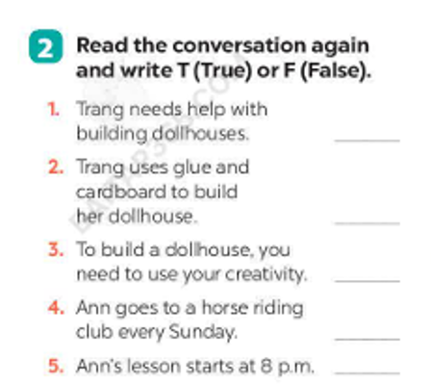Have ss read the conversation and identify if the sentences True or False

- Teacher tells Ss to read the conversation again and work independently to find the answers. Remind Ss to underline the information and correct the false statements.

- Teacher asks Ss to work independently to find the answers.

- Teacher has Ss compare the answers in pairs before checking with the whole class.

- Teacher checks the answers as a class and gives feedback.

**Answer keys:**

*1. F (She made it herself.)*

*2. T*

*3. T*

*4. T*

*5. F (Her lesson starts at 8 a.m.)*

**Activity 6:** **Practicing the vocabulary related to hobbies.**

- Have ss play the game: Find someone who…

- Work in groups. Ask as many classmates as you can about which hobbies they like. Use the question ‘Do you like…?’.

- In the table below, write your classmates’ names beside the activities they like.

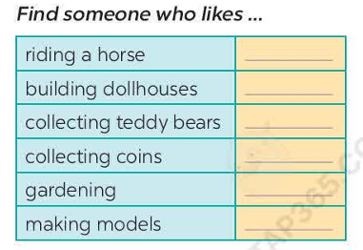

- Teacher lets Ss to move around the class to ask their classmates about their favourite hobbies in 3-5 minutes.

**Sample questions:**

*1. Do you like collecting dolls?*

*2. Do you like collecting teddy bears?*

*3. Do you like riding horses?*

*4. Do you like building dollhouses?*

*5. Do you like gardening?*

- Teacher asks Ss to write the results into the table.

- Then teacher asks some Ss to report their results. Whoever has the most names wins.

- Teacher can ask students to read aloud the full sentences and correct their pronunciation if needed.

**IV. HOME ASSIGNMENTS:**

- Practice the conversation paying attention to pronunciation and intonation.

- Make sentences about hobbies with Do you like…?